Collection of oyster rectal biopsy for RFTM assay for Perkinsus marinus

Standard Operating Procedures

** New participants must be trained by a technician or a post-doc **

Read this protocol and review safety information verbally with the entire collection team before beginning. Contact the project lead with questions.

Contact List
- Project Lead: Calli Wise, wiseca@si.edu, (448) 482-2432 office, (717) 961-0171 cell
- Lab Safety: Calli Wise and/or Ruth DiMaria, DiMariaR@si.edu, (443) 482-2473 office

I. Goals
Identify infection status and intensity in oyster or clam tissue.

II. Labwork

Supplies:

☐ Sterile snap-cap culture tubes, 1 per sample
☐ Sterile transfer pipettes (>2mL)
☐ Pipettor
☐ Thioglycolate medium or alternative broth mix
☐ Chloramphenicol
☐ Nystatin
☐ NaCl
☐ Lugol’s (concentrated and/or diluted 1:3)
☐ Parafilm or disposable weigh boat
☐ Digital Caliper
☐ Dissecting scissors
☐ Glass or metal hook tool
☐ Forceps
☐ Metal needle tools
☐ Oyster knife (shucking oysters)
☐ Scalpel (shucking clams)
☐ 1 chain mail gauntlet
☐ Nitrile gloves
☐ Laboratory trays
☐ Lab tape
☐ Sharpie
☐ Glass beakers ~100 ml
☐ Glass 250 or 500mL autoclavable bottles
☐ Glass flask 3000mL
☐ Microscope Slides (2 per sample)
☐ Glass squash plate (to protect scope from iodine)

Lab Safety SERC Security: (443) 482.2298
- While on SERC property, anyone with an SI badge must have it on their person at all times.
- Close-toed shoes are required in the lab at all times.
- Nitrile gloves are required when using chemicals and are recommended when handling glass slides, shells, and tissue.
- Dispose of any broken glass and used coverslips in the sharps container.
- Contact Project Lead for Training for:
  - Autoclave
    - High heat, pressurized steam, and volatilized chemical hazards
    - Must wear autoclave gloves and fill out physical use log on the machine
  - Shucking
    - Sharp tools and sharp shell hazards
  - Sediment Sinks
    - Must use filters and plugs appropriately or risk damaging SERC drainage system
- Contact Lab Safety Reps with questions or concerns.
Chemical Preparation:
Media and Nystatin solutions should be created at least a day before they are needed.
RFTM tubes can be prepared the day before expected dissections.
Create RFTM media (Steps 1 – 6) and Nystatin base (Step 1) before using the autoclave to sterilize all liquids. Weigh ingredients on sterile parafilm or a disposable weigh boat.

Nystatin Solution
Ingredients for 125mL of Nystatin Solution
Nystatin powder-500,000 units (0.08497 g)
Distilled water-125 ml

- Add 125 ml distilled water to a 250 ml screw cap autoclavable Erlenmeyer flask.
  - Screw on caps, then loosen back off ¼ turn to allow steam to escape during autoclaving
  - Add sterilization tape to each lid.
- Autoclave for 15 minutes at 121 C (250F) to sterilize.
- Cool, then add Nystatin powder.
- Store in the refrigerator at 4 C for up to 3 months or freeze at -20C indefinitely.
- Shake well before using.

Example calculation: based on current nystatin stock powder bottle
500,000 units x 1 mg/5884units
500,000/5884 =84.976 mg x 1 g/1000 mg = 0.08497 g
Chloramphenicol Stock
Recipe for 50mg/mL chloramphenicol stock (suitable to treat 20 x 500mL bottles of RFTM media)
100% ethanol-10 ml
Chloramphenicol powder-0.5 g DANGER - handle with care

- In a sterile 15 ml centrifuge tube combine 100% ethanol and chloramphenicol powder.
- Store at -20 C indefinitely.

RFTM Media
Protocol consumes ~ 2mL media per sample, scale recipe for expected sample size.
Ingredients for 4 x 500mL bottles of Ray’s fluid thioglycollate medium (RFTM).
1980mL distilled water
40 g NaCl
58.4 g Thiglycollate medium or alternative broth mix

- Add distilled water to a 3000mL glass beaker on a stirring hot plate. Keep stirring on.
- Measure and add NaCl.
- Measure and add Thioglycollate medium powder.
- Continue stirring and bring to a boil until all ingredients are fully dissolved.
- Remove from heat
- Carefully dispense into autoclavable bottles. Do not fill the bottles beyond 2/3 full.
  - Screw on caps, then loosten back off ¼ turn to allow steam to escape during autoclaving
  - Add sterilization tape to each lid.
- Autoclave for 15 minutes at 121 C (250F) to sterilize
- Cool, then add 0.5 mL of 50mg/mL chloramphenicol stock to every 500mL cooled media.

Store RFTM at room temperature in the dark for ~ 2 months. Do not use if cloudy or has floating substances.

RFTM Tube Preparation:
- Number the sterile snap-cap tubes and label racks appropriately. Open each tube.
  - Can open multiple tubes simultaneously and keep lids clean on paper towels.
- Using sterile transfer pipettes, fill each with ~2 ml prepared RFTM media.
- Add 2-3 drops of Nystatin to each tube with a pipette dropper.
  - Allow nystatin to float on the surface, do not mix or shake tubes after this point.

Bivalve Dissection:
RFTM uses clean (not sterile) methods. If project includes other sampling (e.g. genetics / microbiome) you may need to shuck and dissect using sterile techniques and flame sterilization (requires additional training).
- Clean oysters using an outdoor hose and/or scrub brushes in the sediment sink to remove debris.
  - Clams do not require scrubbing.
- Measure and lay out oysters on tape-labelled lab trays or measure clams and store individually in labelled sample cups.
  - Record collection site and any pre-existing shell damage before shucking.
  - Record additional data as necessary based on project goals.
- Shuck each oyster or clam following clean techniques (rinse tools between organisms).
  - Oysters
    - Wear a chainmail glove and shuck the oyster at the umbo with the left valve down, careful not to pierce body tissue
    - Sever the muscle to free the top (right) valve
  - Clam
    - Wear a chainmail or soft cut-proof glove
    - Slip a scalpel between the valves near the umbo with the left valve down, while aiming toward the top shell to avoid the body tissue
    - Sever the muscle to free the top valve
- Sample Tissues
  - Oyster (Figure 1)
    - Using dissection scissors and forceps, cut a 0.5 mm strip of rectum tissue and add it to the prelabelled tube of RFTM media.
    - Use forceps to clear fecal material away from the rectum before collection (limit contaminants in the media)
      - Tissue volume matters for incubation and scoring, aim to consistently collect a ~5mm snip
    - Using the same dissection scissors and forceps, cut a 0.5mm wedge of mantle tissue from opposite where the rectal tissue was collected and add it to the same tube of RFTM media as the rectum.
      - Tissue volume matters for incubation and scoring, aim to consistently collect a ~5mm snip
  - Clam (Figure 2)
    - Secure both palps using forceps and cut them free using dissection scissors
    - Collect both whole palps from clams simultaneously, they are likely to be smaller than 5mm and are easily lost in the body cavity if not held with forceps.
- With minimal disturbance to the media, use a long glass or metal wand to push the sample tissues tissue below the floating layer of nystatin so they sink to the bottom of the culture tube.
- Rinse dissection tools and shucking knife in water between animals. Refresh the water if it gets cloudy.
- After completing all samples for the day, incubate culture tubes in the dark at 28 C for 5-7 days.
- General Cleanup: Wipe and bleach counters. Rinse and dry lab trays and tools. Wipe up and discard any debris from the sink and clean the sink strainer into the trash.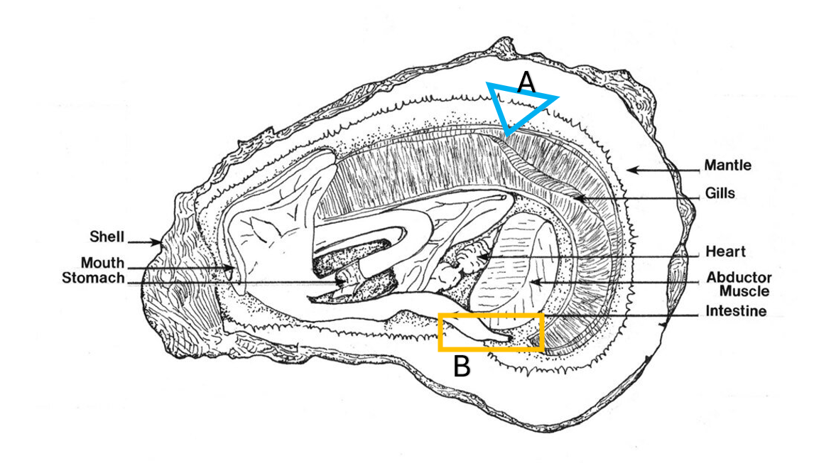
Figure 1. “Oyster Anatomy” by Louisiana Sea Grant CC BY 2.0 with edits to show tissue samples. A) Mantle Sampling location (blue). Snip a 5mm wedge of mantle tissue, avoiding the gills and other tissues. B) Rectum Samplign Location (orange). Snip a 5mm length of the tube (often light pink) at the termination of the intestine, found along the exterior edge of the adductor muscle. Location may shift during shucking. If present, press out and avoid feces before taking the sample.

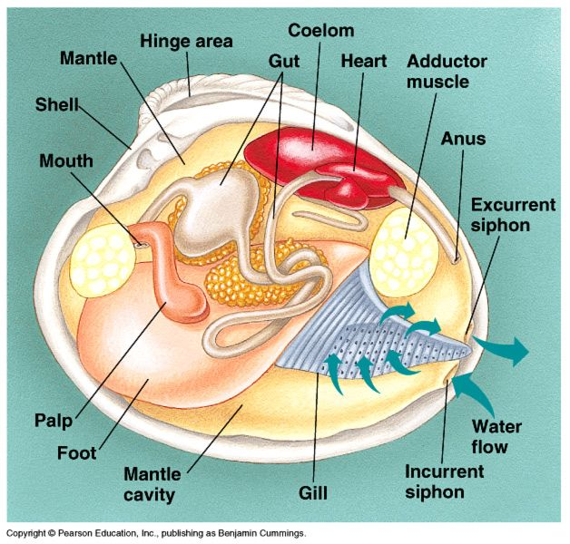
Figure 2. Clam Anatomy Diagram. Palps are paired and wrapped around the mouth.
Slide preparation:
You can prepare slides in batches. Slides are OK at room temperature for a few hours. Keep Lugol’s and stained slides out of direct sunlight.
- Retrieve the culture tubes from the incubator after 5 – 7 days of incubation.
- Lay out and label a microscope slide for each sample tube
- Open the culture tube and use a long metal hook to place each tissue it on the slide (Figure 3).
  - Oyster – place the mantle on the left and the rectum on the right to follow the data sheet
  - Clam – place one palp on each side of the slide

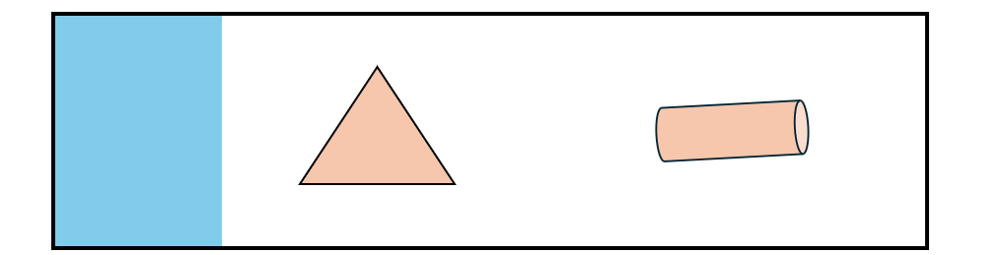
Figure 3. Microscope slide, labelled with sharpie on the glossy portion (washes off easily) with mantle tissue (left) and rectal tissue (right). Each tissue will be scored separately.

- Use forceps and metal needle tools to tease apart each tissue one at a time. Rinse your tools in water between tissues, and between animals.
  - Refresh the water if it becomes dirty
- After each tissue is liquified, add 1-2 drops of Lugol’s iodine, and mix each tissue using a metal tool to stain cells evenly. Rinse the tools between tissues and animals.
  - Use the 50mL working aliquot of appropriately concentrated Lugol’s in the CDE cabinet.
  - Test the concentration and # drops used to stain your first slide before staining additional slides.
    - Stain should be concentrated enough to stain Perkinsus cells, but not so concentrated that all of the oyster tissue turns dark red/opaque and is impossible to see through when squashed.
  - Contact the project lead if the working aliquot is empty or for help troubleshooting.
- Let stained tissues sit for ~ 30 seconds uncovered, then add a second microscope slide as a top cover. Slides are now ready to be scored.
  - You can store batches of stained slides on metal slide racks available in the CDE lab.

Reading Slides:

Use a glass squash plate to protect your dissecting scope from iodine stain that may leak out of slides. Adjust slide preparation method if slides are too wet, tissue is not sufficiently shredded, or stain is too concentrated. Each tissue (mantle, rectum, palp 1, palp 2) is counted and scored separately.

1. Gently compress the prepared slide to squash stained tissue flat.
2. Scan each tissue under 4x magnification and follow the guide in Table 1 to fill out the data sheet. Positive infections of Perkinsus sp. appear as symmetrical round blue-black or solid black spheres. Staining is not always uniform or complete and may appear clear or icy blue.
- Count and record exact number of cells present in the whole tissue sample if <100 cells
- If >100 cells per tissue, estimate cell count as 100-1000 (score 1) or >1000 (score 2)
- If >1000 cells per tissue, observe only a 5mm field of squashed tissue and estimate cell count:
  - 30-300 cells / 5mm field (score 3)
  - 300-1000 cells / 5mm field (score 4)
  - >1000 cells / 5mm field (score 5)
3. Score each tissue separately (mantle and rectum for oyster, palp 1 and palp 2 for clams)
4. Once scoring is complete for both tissues on a slide, use a paper towel strip to wipe the stained tissue into a waste bag.
a. When starting a new project or sampling event, save slides on racks for a second reader to confirm counts and scores. This helps re-orient reader judgement.
5. Wash slides using soapy water and a soft brush followed by DI water rinse to prevent residue. Set slides to dry on clean paper towels.
6. General Cleanup: Wipe up and discard any debris from the sink and clean the sink strainer into the trash. Wipe down microscope base and workstation. Clean and dry tools.
Material Disposal:

Stained tissue from slides (on paper towels)
- Bag and place into standard waste stream (trash can)
Expired unused RFTM media
- TBD
Expired unused Nystatin solution
- TBD
Used RFTM media in culture tubes (with or without residual tissue)
- TBD

Table 1. CDE Scoring Guide
Score | Cell Count | Description
0 | None | Negative  No cells present in tissue.
0.5 | 1-10  /sample | Very Light  Cells may be clustered or scattered.  Cells often large, but can vary in size.
1 | 11-100  /sample | Light  Cells in most fields, sometimes concentrated in specific areas  Count <100 total cells per tissue sample
2 | 99-1,000  /sample | Light Medium  Cells present in most areas of the tissue, can be patchy or evenly distributed.
3 | 31-300  /5mm field | Medium  Cells generally present everywhere, some areas may be more dense than others. Sometimes small pockets of dark tissue visible macroscopically.
4 | 301-1,000  /5mm field | Medium Heavy  Some small areas of the tissue are have less dense or no cells.  Large areas of tissue on slide are black macroscopically.
5 | >1,000  /5mm field | Heavy  Tissue is packed with cells.  Tissue is entirely black when viewed macroscopically.  May feel “gritty” when squashed.  May be extremely tiny scraps of less infected/uninfected tissue. Check carefully for uninfected cells (can be hard to stain evenly when extremely dense).
Coastal Disease Ecology – RFTM Dermo Scoring Guide

Table 1 is a combination of a scoring scale modified from Mackin and cell concentration/overall tissue appearance modified from Bobo. For the CDE lab’s Leica scope, the 15x ocular at 4x magnification yields the required 5mm field of view to count cells for samples with infection intensity scores of 3-5. See Table 2 for examples of each infection intensity score. See Table 3 for likely features of Perkinsus cells.

For additional information see : RFTM_BivalveDisease_CDELabMeeting2024.06.07.pptx

Table 2. Infection Intensity Examples
Score | Example Image from Oyster Tissue
0.5 | 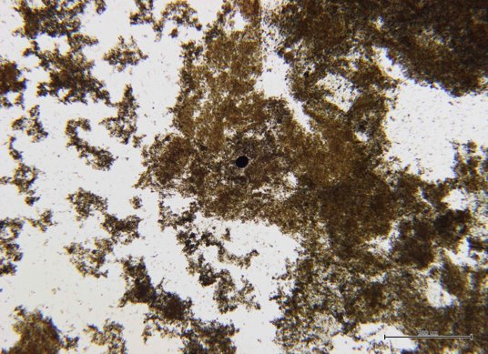
1 | 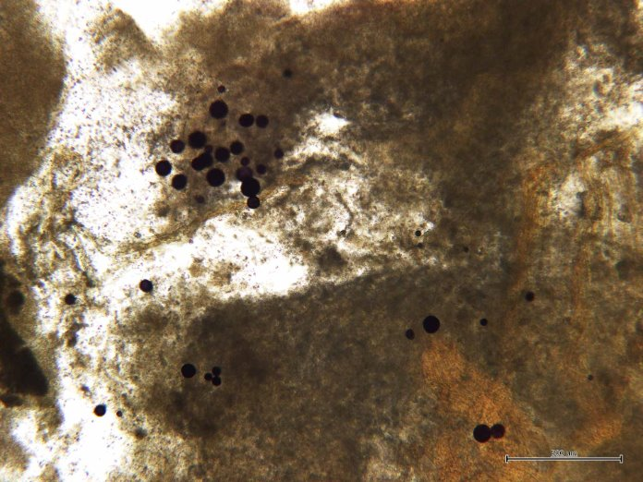
2 | 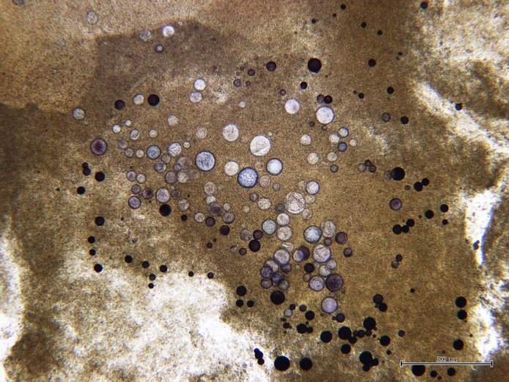
3 | 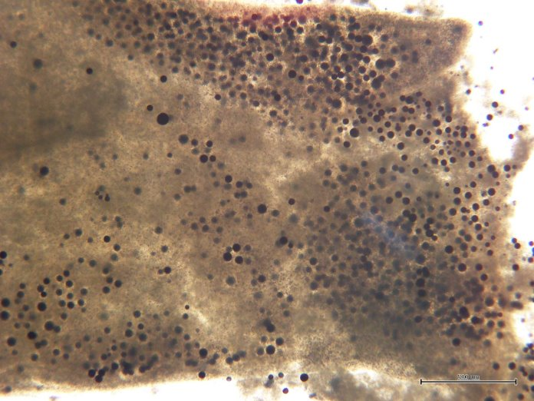
4 | 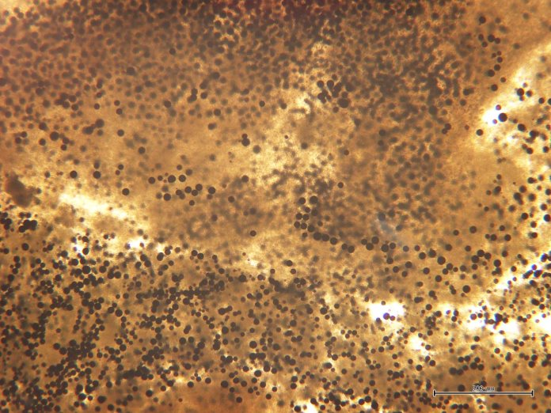
5 | 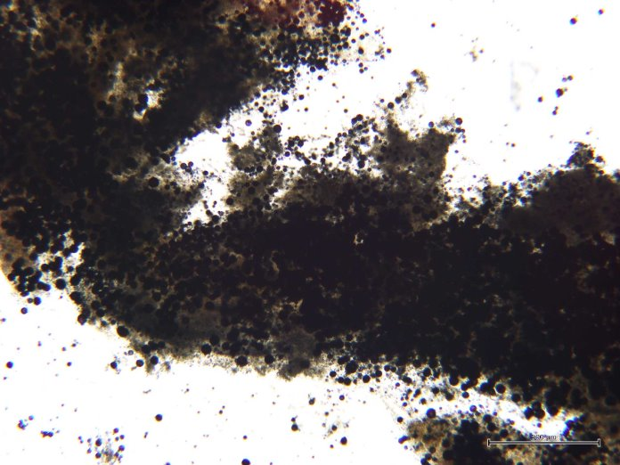

Table 3. Perkinsus Features
Likely Perkinsus | Not Likely Perkinsus
- 10-250 um  - Spherical  - Smooth walled  - Refractile  - Staining blue-black (variable from unstained clear to solid blue-black)  - “Pacman” when squished | - Angular or faceted  - Fuzzy surface  - Non-refractile  - Staining having brownish or reddish tinge  - Chorion or clear halo surrounding stained center  Commonly seen suspicious objects:  - Pollen grains  - ‘Mickey Mouse’ cells  - Eggs and egg-like structures (clear halo)  - Black or grey grit, usually associated with fecal material  - ‘Little black bodies’ <10 um  - Brownish staining special or ovoid cells  - Unstained round cells with intracellular ‘teeth’

